**Prerequisites: Arduino IDE Installed**

**Installing ESP32 Add-on in Arduino IDE**

**To install the ESP32 board in your Arduino IDE, follow these next instructions:**

1. **In your Arduino IDE, go to File> Preferences**

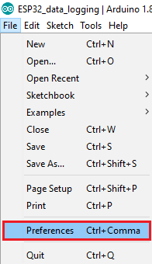

1. **Enter the following into the “Additional Board Manager URLs” field:**

https://raw.githubusercontent.com/espressif/arduino-esp32/gh-pages/package_esp32_index.json

**Then, click the “OK” button:**

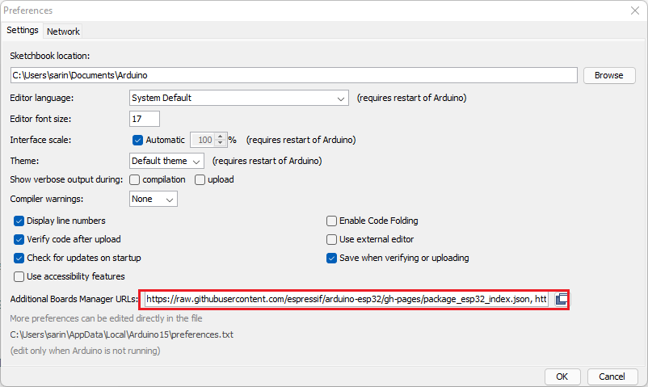

**Note:** if you already have the ESP8266 boards URL, you can separate the URLs with a comma as follows:

https://raw.githubusercontent.com/espressif/arduino-esp32/gh-pages/package_esp32_index.json, http://arduino.esp8266.com/stable/package_esp8266com_index.json

1. **Open the Boards Manager. Go to Tools > Board > Boards Manager…**

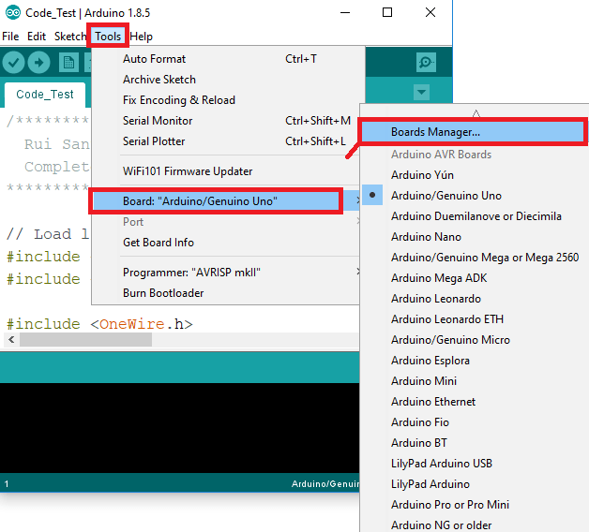

1. **Search for ESP32 and press install button for the “ESP32 by Espressif Systems“:**

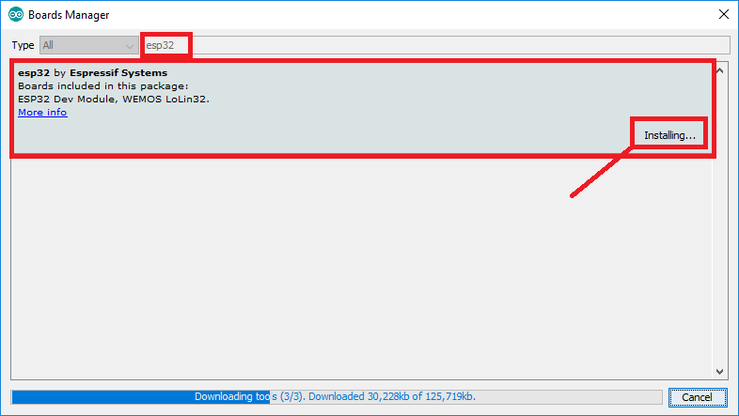

1. **That’s it. It should be installed after a few seconds.**

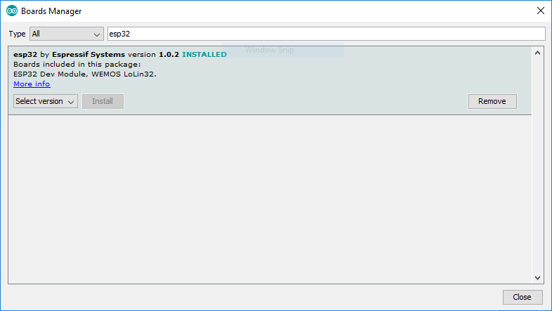

**Testing the Installation**

**Plug the ESP32 board to your computer. With your Arduino IDE open, follow these steps:**

1. **Select your Board in Tools > Board menu (in my case it’s the DOIT ESP32 DEVKIT V1)**

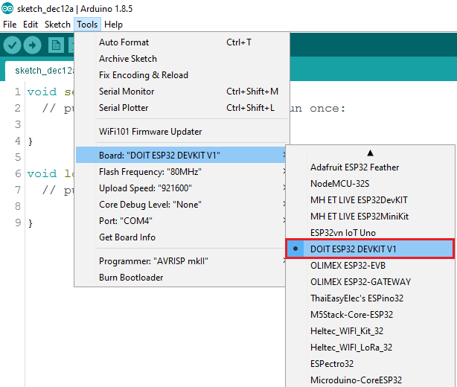

**2. Select the Port (if you don’t see the COM Port in your Arduino IDE, you need to install the**[**CP210x USB to UART Bridge VCP Drivers**](https://www.silabs.com/products/development-tools/software/usb-to-uart-bridge-vcp-drivers)**):**

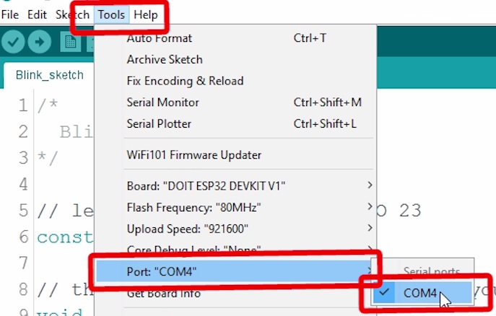

1. **Open the following example under File > Examples > WiFi (ESP32) > WiFiScan**

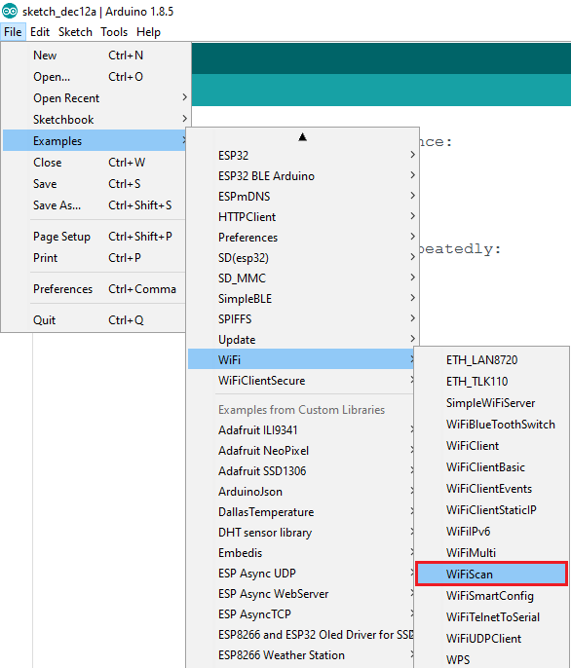

**4. A new sketch opens in your Arduino IDE:**

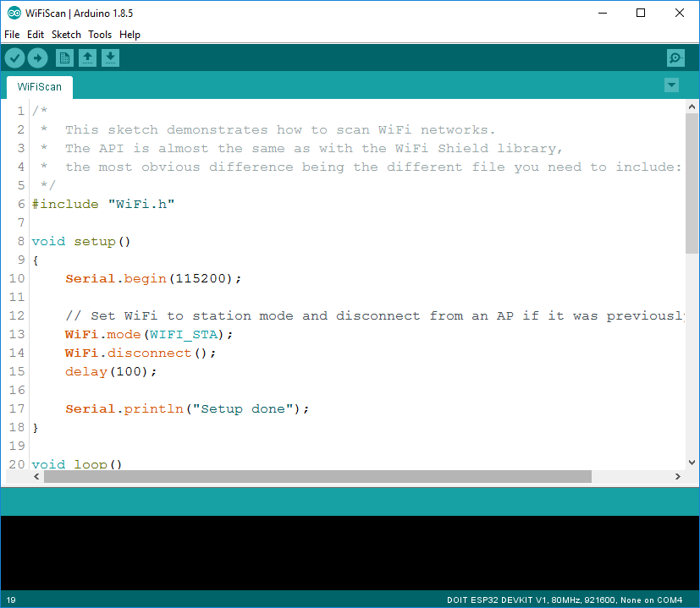

1. **Press the Upload button in the Arduino IDE. Wait a few seconds while the code compiles and uploads to your board.**
2. **If everything went as expected, you should see a “Done uploading.” message.**

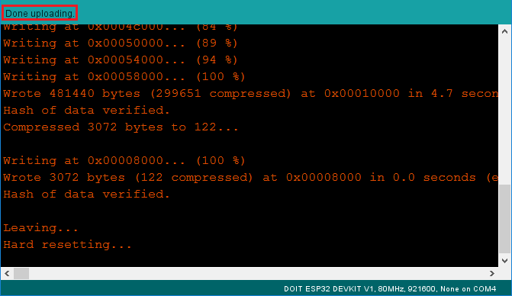

**7. Open the Arduino IDE Serial Monitor at a baud rate of 115200:**

**8. Press the ESP32 on-board Enable button and you should see the networks available near your ESP32:**

